Painkalac Estuary Water Quality Monitoring Program - Summary of Results
From: Stuart Symes <SSymes@surfcoast.vic.gov.au>
Date: Wed, 8 Nov 2023 at 11:41
Subject: Painkalac Estuary Water Quality Monitoring Program - Summary of Results
To: barbara hammond <barbara.hammond@veridica.com>

Hi Barbara,

I am pleased to provide a summary of the Painkalac Estuary Recreational Water Quality Monitoring Program that concluded earlier in the year.

Background
• Sampling program developed by EPA, following community member concern about recreational water quality of the Estuary
• Council agreed to coordinate and fund the sampling program
• EPA agreed to interpret results and provide recommendations

Sampling program
• Conducted by ALS Environmental Pty Ltd
• Performed across four locations (see map below) over 20 weeks when estuary is used most frequented by recreational users (December 2022 – April 2023)
• Tested for enterococci (best indicator for faecal contamination in estuaries)
• Sanitary inspections also completed at same time as sampling (noting down recreational user numbers, activity type, flushing level and rain activity)
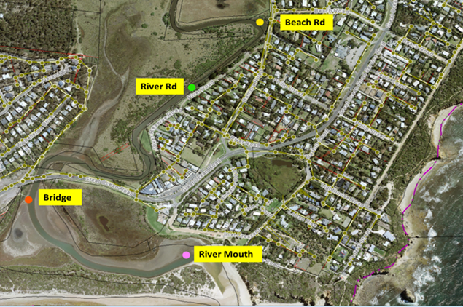

Results
• All results (certificates of analysis) have been attached
• Interpretation by the EPA has also been attached
• Results have been interpreted in accordance with the Australian National Health Medical Research Council Guidelines for Managing Risks in Recreational Water 2008 (the Guidelines)
• Table below summarises results each location (those results in red show where the Guidelines were exceeded)
• Results are what would be expected in an estuary
• River Mouth and Bridge locations are deemed a very low risk of recreational users contracting a gastrointestinal illness during dry weather
• River Road and Beach Road locations were found to pose a high risk of recreational users contracting gastrointestinal illness (6/20 samples taken exceeded the Guidelines for each location)
• EPA recommends signage at all sites to discourage fishing and primary contact recreation (including kayaking) for 48 hours after rainfall
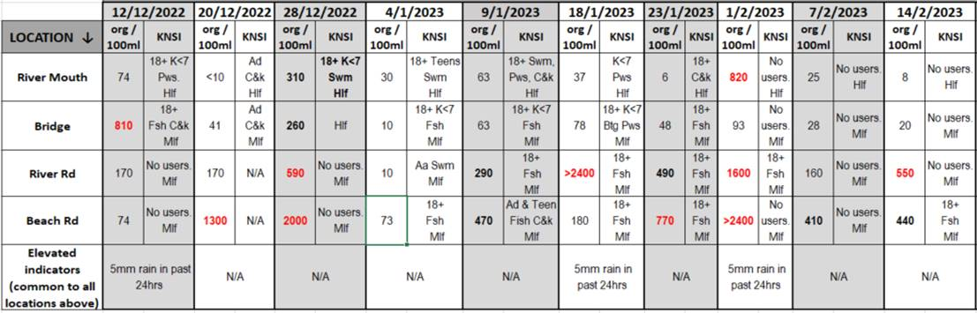
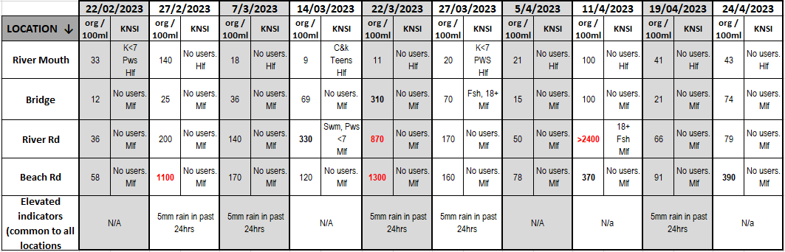

Next Steps
• Council officers to consult with relevant stakeholders about potentially installing signage as per EPA recommendations

I will keep you updated as soon as a decision has been made regarding signage.

If you have any questions, please let me know.

Kind regards

Stuart

Stuart Symes
Coordinator Environmental Health

Wadawurrung Country
1 Merrijig Drive (PO Box 350) Torquay VIC 3228
03 5261 0647 | 0427 144 827 | ssymes@surfcoast.vic.gov.au

Surf Coast Shire spans the traditional lands of the Wadawurrung, Gulidjan and Gadubanud Peoples.
We Acknowledge them as the Traditional Owners and Protectors of this place.
We Acknowledge their Ancestors who cared for the land, rivers and sea - and all of its creatures - for thousands of generations.
We pay our Respects to Elders past, present and future who continue on this path.
Any personal or sensitive information contained in this email and attachments must be handled in accordance with the Privacy and Data Protection Act 2014 and the Health Records Act 2001. This email, including all attachments, is confidential. If you are not the intended recipient, you must not disclose, distribute, copy or use the information contained in this email or attachments. Any confidentiality or privilege is not waived or lost because this email has been sent to you in error. If you have received it in error, please let me know by return email, delete it from your system and destroy any copies. All rights in the information transmitted, including copyright are reserved. No warranty is given by the sender that any attachments to this email are free from viruses or other defects.

Message protected by MailGuard: e-mail anti-virus, anti-spam and content filtering.
https://www.mailguard.com.au
---------- Forwarded message ----------
From: Applied Science Connect <ASConnect@epa.vic.gov.au>
To: Guy Price <GPrice@surfcoast.vic.gov.au>
Cc:
Bcc:
Date: Tue, 3 Oct 2023 02:04:11 +0000
Subject: EPA VIC: Interpretation of results from microbial study of Painkalac Estuary ASR0017573/ENQ116082
CAUTION: Do not click any links or open any attachments unless you trust the sender and know the content is safe.Learn why this is important

OFFICIAL

Hi Guy,

Please see below for the response provided by our Senior Health Advisor – Microbiology expert.

Comments on Surf Coast Shire monitoring results of the Painkalac Estuary.
Interpretation can only be very basic due to the lack of comprehensive data. Salinity data would have been useful for example. Sanitary inspections were only partly completed (only usage part filled), with the sections pertaining to likely sources of faecal contamination not completed.

Based on the information provided, I can provide the following comments:

River mouth:
Some primary contact recreation is taking part in that area. However, only one high level event was recorded after rain and there were no users after rain, which is good news. This is an area where flushing is high.
Based on the data provided, this site has a very low risk during dry weather.

Bridge:
Fishing and canoeing/kayaking are the main activities, with swimming recorded on one occasion. Please not that kayaking may be considered as primary contact activity in some instances.
Only one high level event was recorded after rainfall. However, some activities were recorded within 24 hours of rainfall.
Based on the data provided, this site has a very low risk during dry weather.

River road:
Six high level events were recorded, including three during dry weather. It is however difficult to understand where this contamination is likely to come from without a complete sanitary inspection and possibly some microbial source tracking. The probability of contracting an illness will depend on the source of contamination (drain, human, avian, etc.). It would have been useful to resample when levels were high.
Swimming was recorded at this location. Furthermore, there was some fishing activity taking place after rain.
Overall, the risk of contracting a gastrointestinal illness at this site are high (>10% during high enterococci events) according to the NHMRC 2008 guidelines.

Beach road:
Six high level events were recorded, including three during dry weather. It is however difficult to understand where this contamination is likely to come from without a complete sanitary inspection and possibly some microbial source tracking. The probability of contracting an illness will depend on the source of contamination (drain, human, avian, etc.). It would have been useful to resample when levels were high.
Kayaking and fishing activities were taking place after rain.
Overall, the risk of contracting a gastrointestinal illness at this site are high (>10% during high enterococci events) according to the NHMRC 2008 guidelines.

Exposure to calculate risk during primary contact recreation is usually not per hour. The definition of one exposure is to have the full body submerged 3 times, with ingestion of a volume of water of about 80ml (95th percentile).
The results provided are what would be expected in an estuary, with some run-off due to rainfall and some local sources of contamination flushed by seawater.
Because some recreationists still use the estuary after rainfall, we would recommend signage to be placed at all locations to discourage fishing and primary contact recreation (including kayaking) for 48 hours after rainfall.
It would also be useful to understand where the contamination is coming from during dry weather as some sources such as birds may pose less risks to public health than other sources (sewage for example).

If you have any further questions, you can contact us via contact@epa.vic.gov.au or 1300 EPA VIC.

Kind regards,
Natalie
Science Advisor
Science Partnerships
E
P
A Centre for Applied Sciences, Macleod
Please note I work Monday to Thursday.
epa.vic.gov.au
EPA acknowledges Aboriginal people as the first peoples and Traditional custodians of the land and water on which we live, work and depend. We pay respect to Aboriginal Elders past and present and recognise the continuing connection to, and aspirations for Country.
This email (and any attachments) is for the intended recipient only and may contain privileged, confidential or copyright information. If you are not the intended recipient, any use of this email is prohibited, please notify the sender immediately or contact us on 1300 372 842, or contact@epa.vic.gov.au and delete the original. EPA does not warrant that this email or any attachments are error or virus free and accepts no liability for computer viruses, data corruption, delay or interruption, unauthorised access or use. Any personal information in this email must be handled in accordance with the Privacy and Data Protection Act 2014 (Vic).

This email (and any attachments) is for the intended recipient only and may contain privileged, confidential or copyright information. If you are not the intended recipient, any use of this email is prohibited, please notify the sender immediately or contact us on 1300 372 842 (1300 EPA VIC), or contact@epa.vic.gov.au and delete the original. EPA does not warrant that this email or any attachments are error or virus free and accepts no liability for computer viruses, data corruption, delay or interruption, unauthorised access or use. Any personal information in this e-mail must be handled in accordance with the Privacy and Data Protection Act 2014 (Vic).

